© 2016 Microsoft Corporation. All rights reserved.

This training package content is proprietary and confidential, and is intended only for users described in the training materials. Some elements of this document are subject to change. This document is for informational purposes only. MICROSOFT MAKES NO WARRANTIES, EXPRESS OR IMPLIED, IN THIS SUMMARY.
This content and information is provided to you under a Non-Disclosure Agreement and cannot be distributed. Copying or disclosing all or any portion of the content and/or information included in this package is strictly prohibited. Complying with all applicable copyright laws is the responsibility of the user. Without limiting the rights under copyright, no part of this document may be reproduced, stored in, or introduced into a retrieval system, or transmitted in any form or by any means (electronic, mechanical, photocopying, recording, or otherwise), or for any purpose, without the express written permission of Microsoft Corporation.
Microsoft may have patents, patent applications, trademarks, copyrights, or other intellectual property rights covering subject matter in this document. Except as expressly provided in any written license agreement from Microsoft, the furnishing of this document does not give you any license to these patents, trademarks, copyrights, or other intellectual property.
The example companies, organizations, products, domain names, e-mail addresses, logos, people, places, and events depicted herein are fictitious. No association with any real company, organization, product, domain name, e-mail address, logo, person, place, or event is intended or should be inferred.
The names of actual companies and products mentioned herein may be the trademarks of their respective owners.
Microsoft and the Microsoft products and services listed are either registered trademarks or trademarks of Microsoft Corporation in the United States and/or other countries.

Participant Guide
Azure FastStart : Azure Backup and Site Recovery

Module 1 Lab: Backing Up with ASR
Table of Contents
Lab 1: 3
Overview 3
Exercise 1: Protect your client to Microsoft Azure 5
Exercise 2: Protecting Azure IaaS VM 14
Exercise 3: Protecting SQL Databases to Azure from DPM 21
Exercise 4: Restoring Databases using DPM and Microsoft Azure 29
Appendix A - Post-protection activities 35
Installation of the backup extension 35
Appendix B - Consistency of recovery points 38

Lab 1:
The time to complete this module, including exercises, is 240 minutes.
The key takeaways from this lab are:
- DPM is a simple and powerful backup solution which can backup data & applications from a server’s client
- DPM enables customers to easily extend their on-premises protection to Azure.
- Administrators can monitor DPM (physical, virtual, running on premises, running in Azure) from a single console.

Overview
Fabrikam Inc is a Silicon Valley enterprise which specializes in building custom turnkey solutions in the real estate space. They have 17 branch offices in the U.S and are supported by 3000 full time employees.
Their line of business applications is based on Windows and their endpoint client laptop/desktop are on either Windows 7 or Windows 8
For the purpose of this hands on lab, as an IT administrator of Fabrikam Inc, you have been tasked to define the business continuity & protection policy for the applications, data and client machines (desktop, laptop).
As your IT infrastructure is managed by System Center, you intend to use System Center Data Protection Manager (DPM) to define your backup strategy. You are also interested in exploring how Microsoft Azure can bring down your operational and infrastructure cost by providing a robust offsite backup technology which can replace your aging, expensive tape media. The hands on lab is aimed at bringing you to speed on some of the key capabilities of DPM.

Exercise Details
- Protect files and folders from your laptop to Azure in 10 minutes
- Register your laptop to Azure Backup Service
- Backup a folder on your client to Azure
- Restore a folder on your client from Azure
- Backup Azure Iaas VMs
- Create a VM on Azure
- Backup IaaS VM
- DPM Attach to Azure
- Register DPM to Azure Backup
- Configure SQL Database backup to Azure
- Recover a SQL Database from Azure Backup

Prerequisites
- Internet access
- Azure Subscription and an Operations Management Suite subscription already setup and configured
- You need servers on-premises or in Azure, running:
- System Center Data Protection Manager: This lab doesn’t cover the installation of this server.
- SQL Server: A single database must be created on this server. This lab doesn’t cover the installation of this server.
- Windows 10 client machine

Exercise 1: Protect your client to Microsoft Azure

The time to complete this exercise is 45 minutes.
The key takeaways from this lab are:
- Demonstrate client backup to Azure

Create Azure Backup Vault

- Logon to your Windows 10 client machine.

- To create an Azure Backup Vault to store backup data, Open Internet Explorer and navigate to the Azure Management Portal, https://manage.windowsazure.com.

- Browse to the “+ New” icon at the bottom of the portal:
- Select Data Services\Recovery Services\Backup Vault\Quick Create and then create a backup vault with the name “SalesVault”. Choose the region “Central US”.

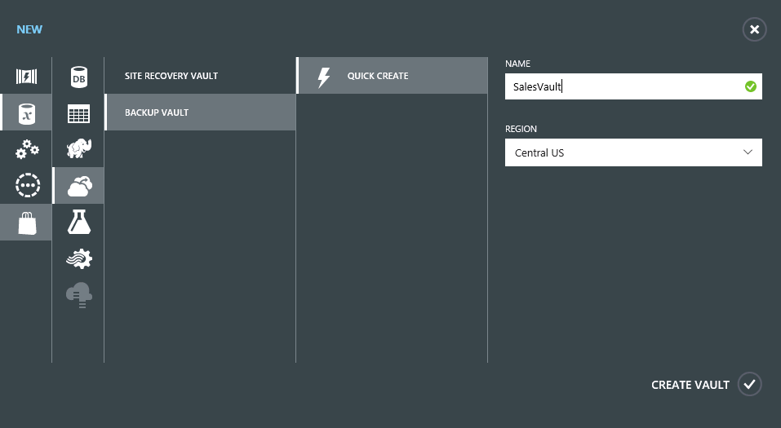
- Click on “CREATE VAULT” icon.
- Go to the main Azure Portal Page and then select Recovery Services from the left-hand side and then select SalesVault:

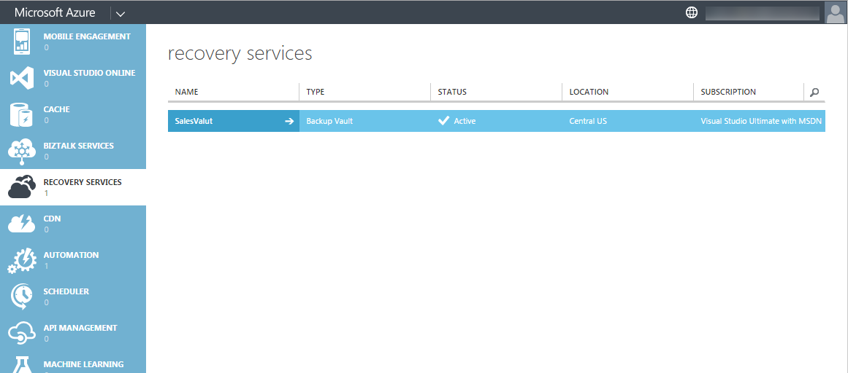

- On the main dashboard screen, review the instructions and then select “Download Vault” Credentials” and then save it to your system’s Desktop.
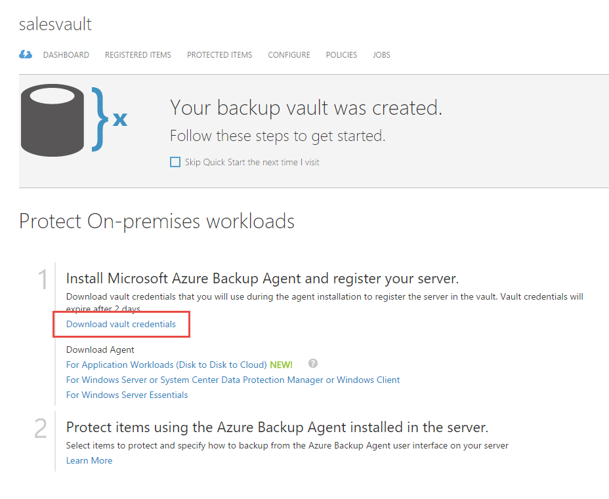
- On the same page, also download the Microsoft Azure Backup Agent for Windows Server or System Center Data Protection Manager or Windows Client (MARSAgentInstaller.exe) to your desktop:

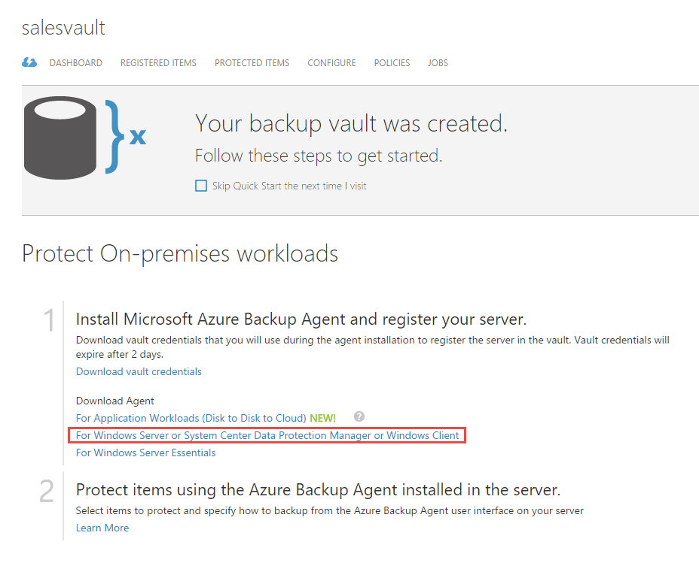

Register the Win10 client machine to the Azure Backup Service

- Install the MARSAgent by clicking on the MARSAgentInstaller.exe downloaded in the previous section. Once installation has completed, click on Proceed to Registration:
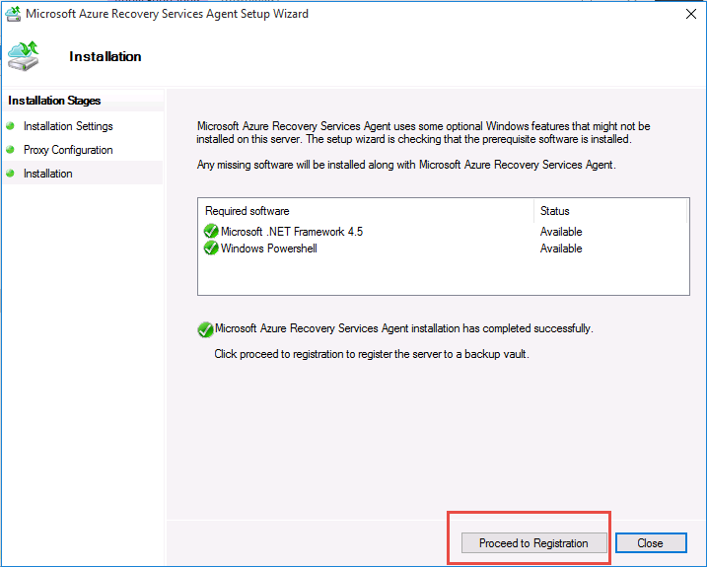

- In the Vault Identification dialog, browse to and select the vault credential file that was downloaded in the last section and then click Next:
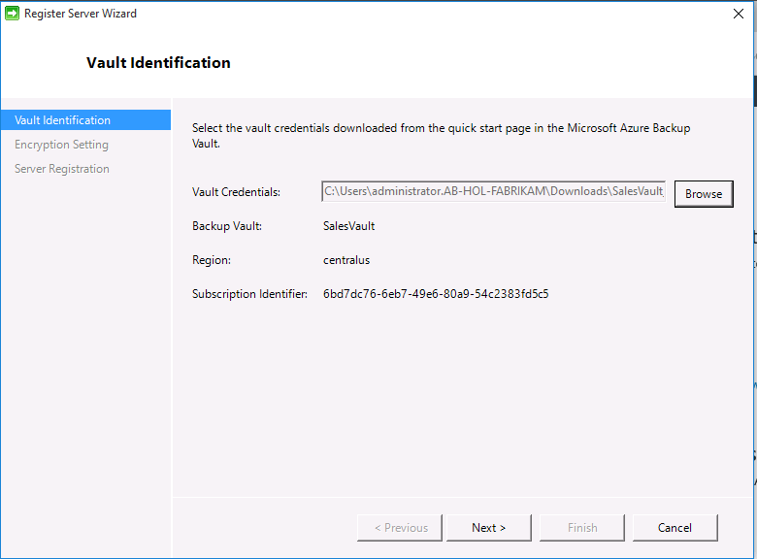

- Enter a Passphrase at least 16 characters or longer. Store the Passphrase file on local directory and click Finish as shown:
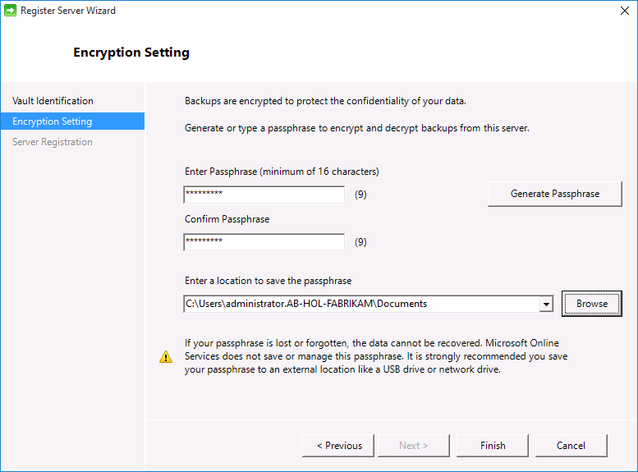
- In the ending dialog, keep the “Launch Microsoft Azure Recovery Service Agent” checked and click Close.
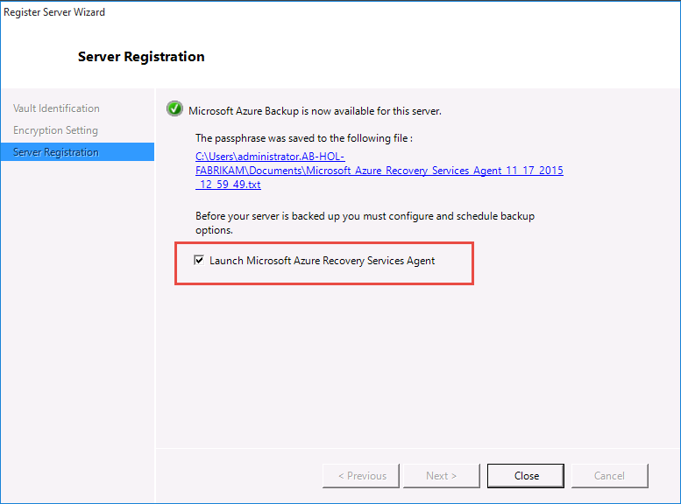

Protecting your Client using Microsoft Azure Backup

- Create a folder called AB-HOL-Azure-Backup in the C:\ folder and copy some files into it. (For example: Copy the MARSagent installer and your Vault Credential settings into the folder.)
- Navigate back to the Microsoft Azure Backup application and click on Schedule Backup.
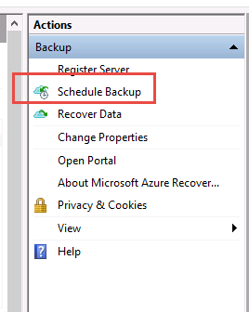

- Click Next at the Getting Started dialog.
- In the Select Items to Backup dialog, select the Add Items button and select the folder that you created in Step A. Click OK and then Next.
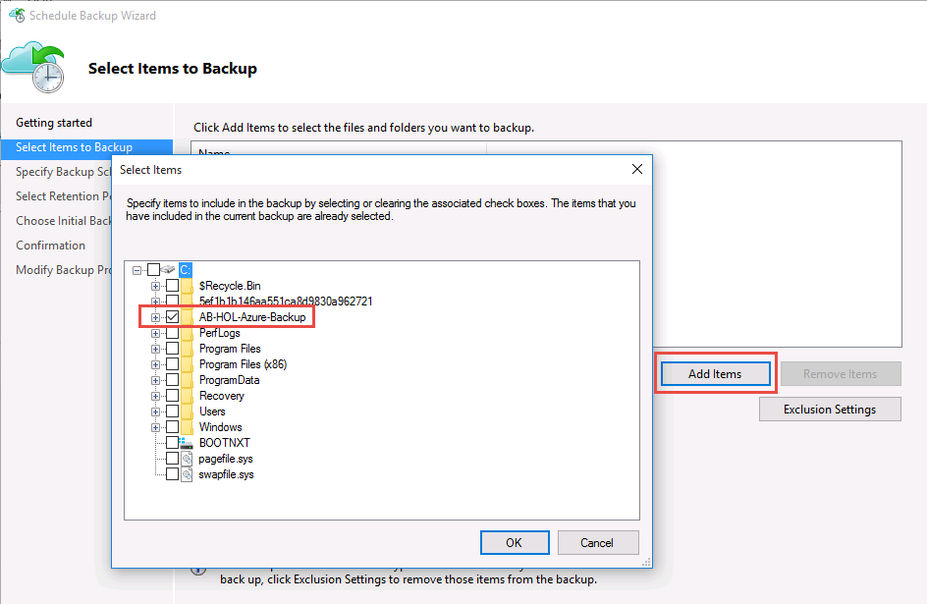
- In the Specify Backup Schedule dialog, specify daily time to backup data as shown below and then click Next:
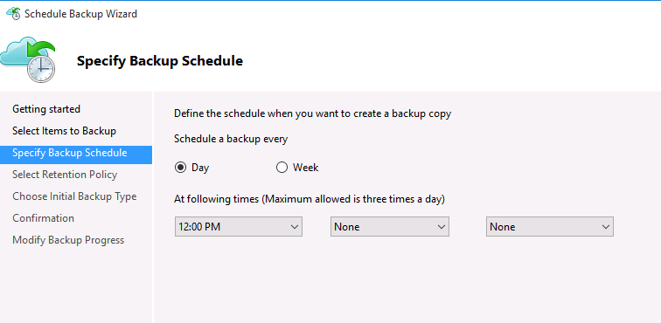
- In the Select Retention Policy dialog, leave the default settings and then click Next.
- In the Choose Initial Backup Type dialog, leave the default settings and then click Next.
- In the Confirmation dialog, leave the default settings and then click Finish.
- In the main window of the Microsoft Azure Backup application, click on Backup Now in the Actions menu:
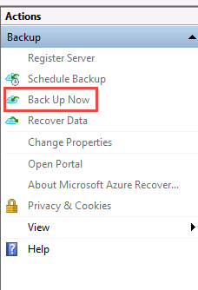
- In the Confirmation dialog of the Back Up Now Wizard, ensure that the folder you created at the beginning of this section is listed in the backup and then select Backup.
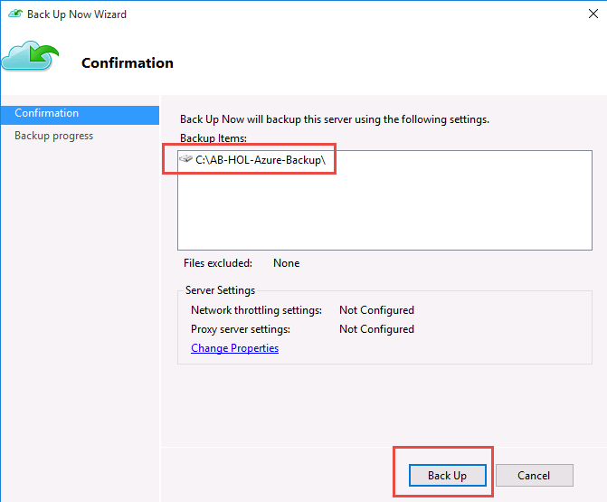
- Your files will now be backed up to Azure.

Restoring files to your Client using Microsoft Azure Backup

- On your C:\ drive, delete the AB-HOL-Azure-Backup folder using File Explorer.
- In the Microsoft Azure Backup application, select Recover Data from the Actions menu:
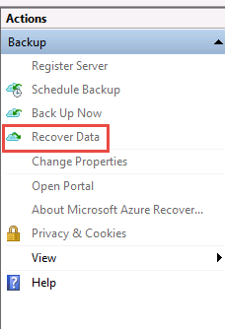
- In the Getting Started dialog, leave the defaults and click Next.
- In the Select Recovery Mode dialog, keep the defaults and click Next.
- In the Select Volume and Data dialog, select volume C:\ and then click Next.
- In the Select Items to Recover dialog, leave the defaults and then click Next.
- In the Specify Recovery Items dialog, leave the defaults and then click Next.
- In the Confirmation dialog, click Recover.
- After the restore has completed, verify that your files were indeed recovered using File Explorer.

Exercise 2: Protecting Azure IaaS VM

The time to complete this exercise, is 45 minutes.
The key takeaways from this lab are:
- Protecting Azure VMs

- Log into AB-HOL-DPM1. Login name is AB-HOL-FABRIKAM\BkpAdmin1 and password is DPMDOMAIN~1
- Launch Chrome Browser by clicking Chrome icon as shown below:

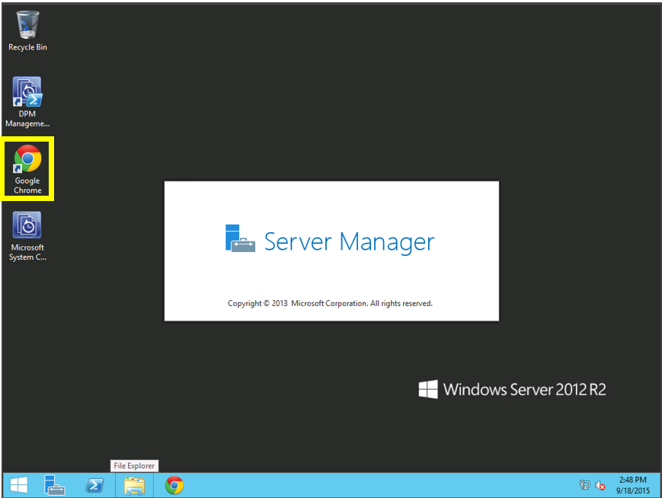

- Navigate to Azure Management Portal, https://manage.windowsazure.com.
- Login into your Azure Subscription
- Create a VM by clicking New, Compute, Virtual Machine, From Gallery as shown below: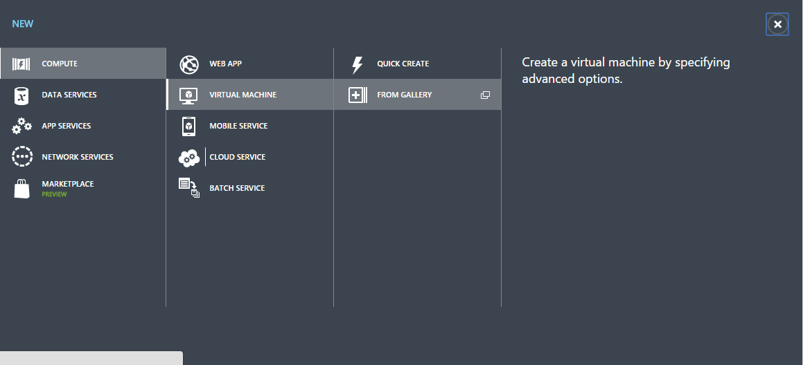

- In the Choose an Image dialog, select Windows 2012 R2 Datacenter as shown below:

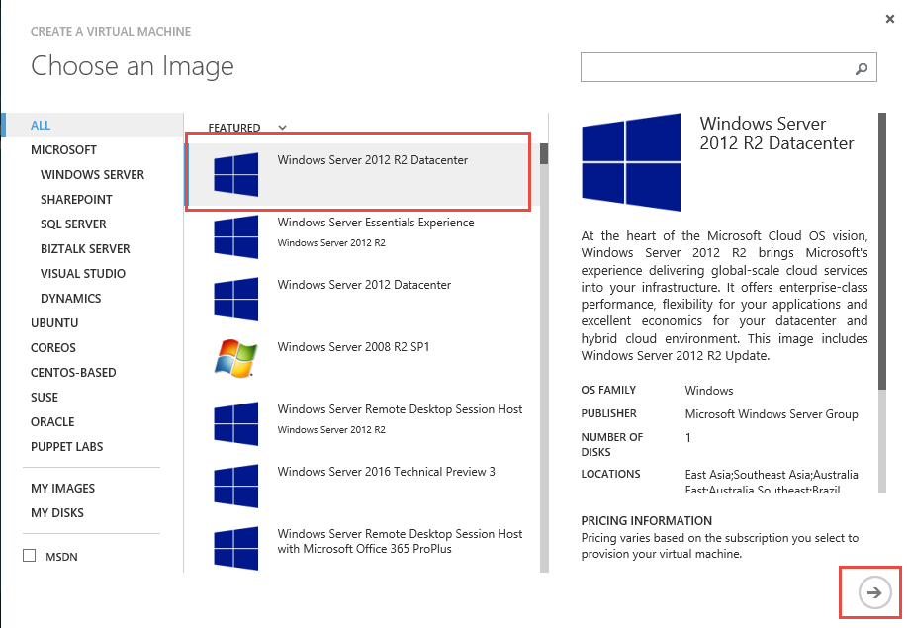

- Specify the machine name as AB-HOL-W2K12R2 and add user name as Admin123 and a password of your choice then select the next page:

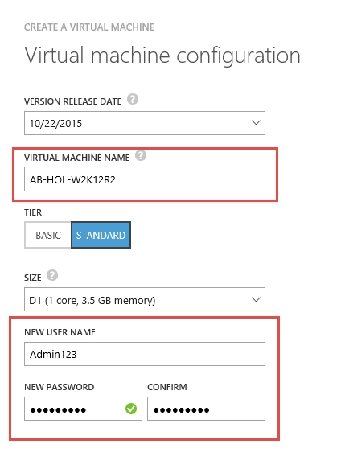

- Ensure that you have a unique Cloud Service DNS Name, that the region is in Central US, and then create the VM. (Note: The Cloud Service Name can be anything you like)
- Click for the next page
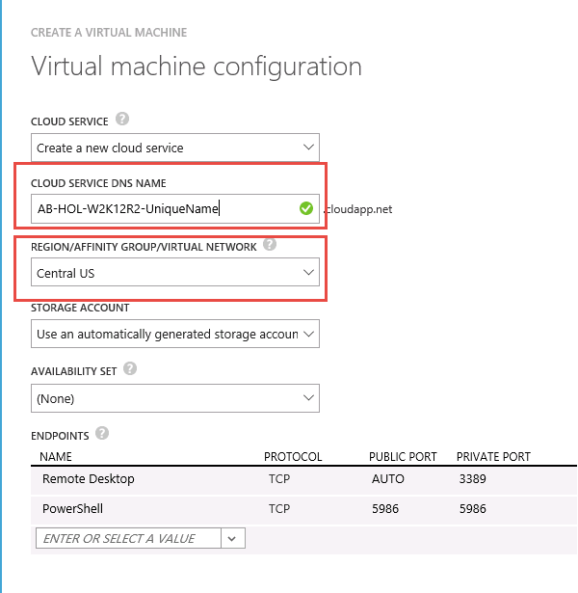

- Click for the next page

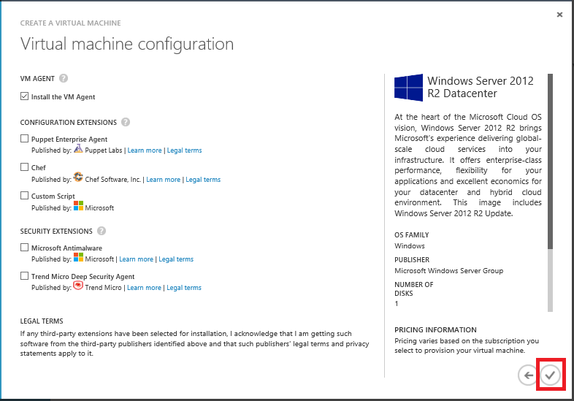

- Select OK to start the VM creation process.

Configure IaaS VM Protection
- Ensure that the VM that you created in the last section has completed successfully and is running.
- Navigate to Azure Management Portal, https://manage.windowsazure.com.
- Login into your Azure Subscription.
- In the portal, click Recovery Services on the left pane and then click on SalesVault that you created in the previous exercise.

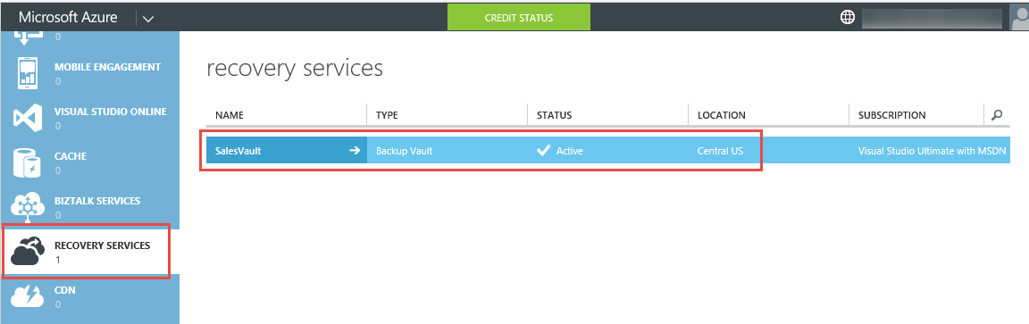

- In the SalesVault main page, select Registered Items.
- Ensure that the Type = “Azure Virtual Machine” and then click Discover at the bottom of the page: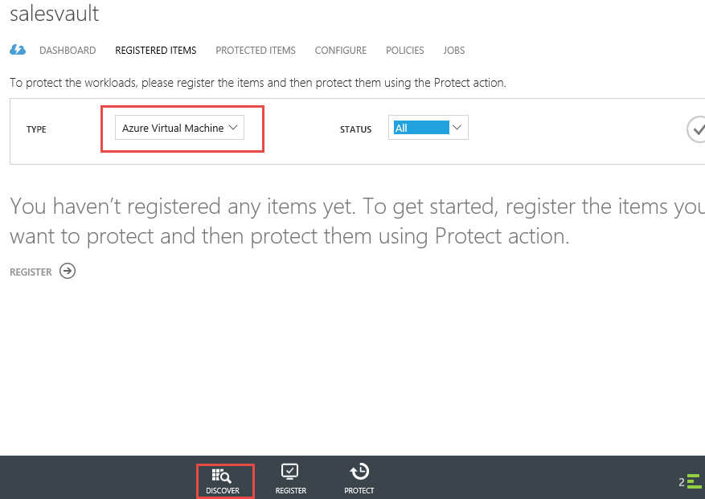

- After Discover has completed, click REGISTER at the bottom of the page. The Register Items wizard appears. This wizard only lists virtual machines which are not registered or protected.

- Select the checkbox of the AB-HOL-W212R2 VM that we created in the last step.
Note: If you do not see a VM, then it is most likely that the VM is in a different region than SalesVault

- Click the arrow circle on the lower right hand corner of the wizard.

- Click PROTECT at the bottom of the page. The Protect Items wizard appears.

- Select the checkbox of the AB-HOL-W212R2 VM and choose next.

- In the second screen of the Protect Items wizard, choose a backup schedule to back up the selected virtual machines. Pick from an existing set of policies or define a new one.
In each backup vault, you can have multiple backup policies. The policies reflect the details about how the backup should be scheduled and retained. For example, one backup policy could be for daily backup at 10:00 P.M., while another backup policy could be for weekly backup on Saturday at 6:00 A.M. Multiple backup policies allow flexibility in scheduling backups for your virtual machine infrastructure.
Each backup policy can have multiple virtual machines that are associated with the policy. The virtual machine can be associated with only one policy at any given point in time.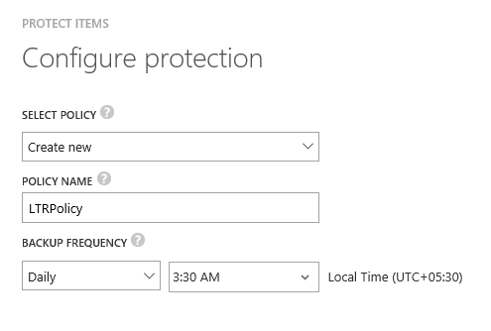

- In the third screen of the Protect Items wizard, choose a retention range to be associated with backups taken. This screen supports industry standard GFS(Grandfather-Father-Son) based retention scheme. Read more about long Term retention.
A backup policy also involves retention scheme of the scheduled backups. Selecting an existing backup policy in previous screen disables modification of the retention scheme and backups follow the retention policy as defined in the policy.

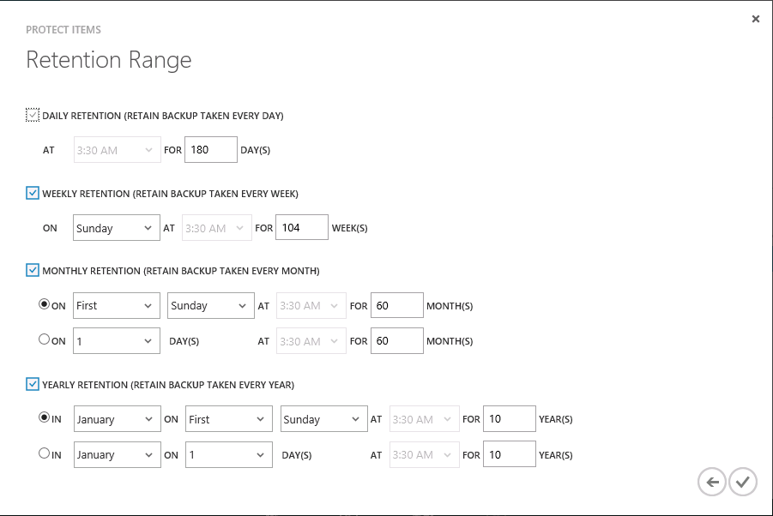

- A job is created for each virtual machine to configure the protection policy and to associate the virtual machines to the policy. Click the Jobs tab and choose the right filter to view the list of Configure Protection jobs.

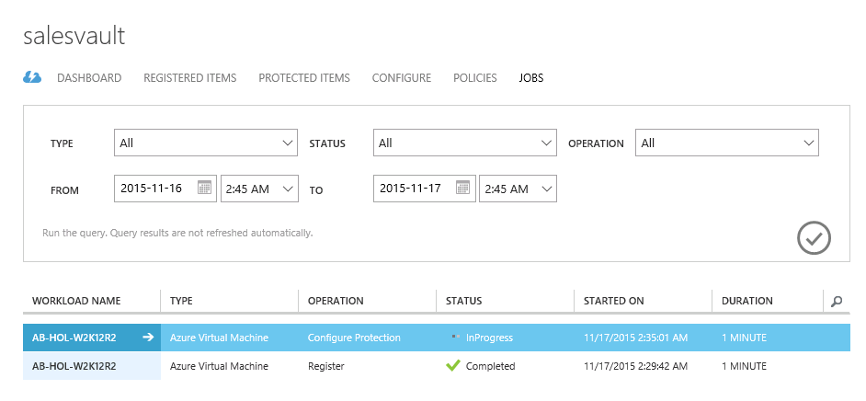

Exercise 3: Protecting SQL Databases to Azure from DPM

The time to complete this module, including exercises, is 30 minutes.
The key takeaways from this lab are:
- How to protect SQL Databases to Microsoft Azure with Microsoft Data Protection Manager

Register DPM with Azure Site Recovery
- Log into AB-HOL-DPM1. Login name is AB-HOL-FABRIKAM\BkpAdmin1 and password is DPMDOMAIN~1
- Launch Chrome Browser by clicking Chrome icon as shown below:

- Navigate to Azure Management Portal, https://manage.windowsazure.com.
- Login into your Azure Subscription
- In the portal, click Recovery Services on the left pane and then click on SalesVault that you created in the previous exercise.

- In the SalesVault main page, download the vault credentials and Chrome will store them in the downloads folder of user profile C:\Users\BkpAdmin1\Downloads folder.

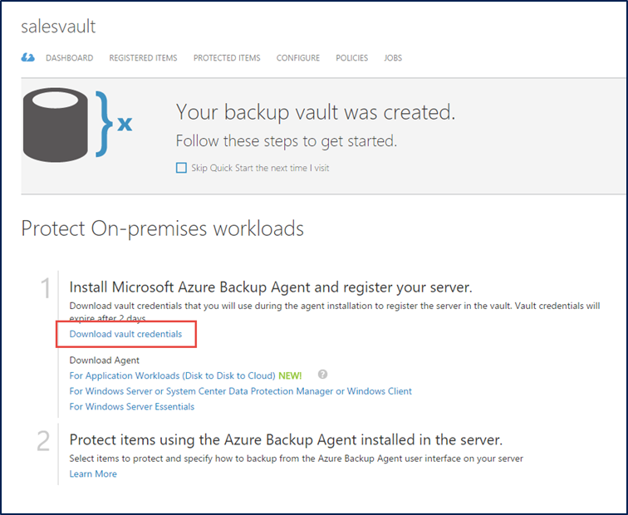

- On the same page, also download the Microsoft Azure Backup Agent for Windows Server or System Center Data Protection Manager or Windows Client (MARSAgentInstaller.exe) to the user profile downloads folder: C:\Users\BkpAdmin1\Downloads

- On, AB-HOL-DPM1, install the downloaded agent (MARSAgentInstaller.exe). Instructions on how to do this are located in Exercise 1 of this lab.
- Open the System Center 2012 R2 DPM Administrator Console shortcut located on the desktop.

- In the DPM Console, select the Management pane and then select Online:
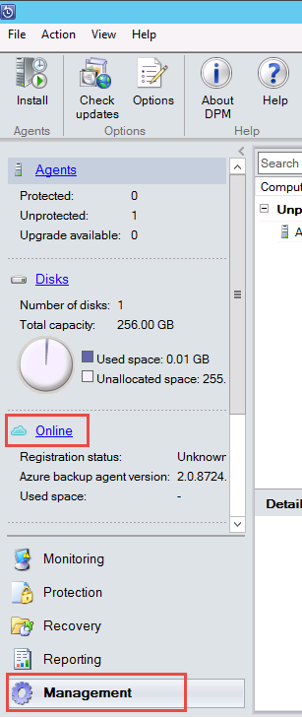
- Next, click on Register on the top ribbon:
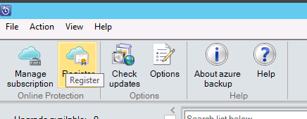
- In the Register Server Wizard, click Next on the Proxy Configuration dialog.
- In the Vault Configuration dialog, browse to and select the vault credential you downloaded earlier.
- In the Network Throttling dialog, leave the defaults and select Next.
- Using File Explorer, create a folder on the C:\ drive named RecoveryTemp.
- In the Recovery Folder dialog, enter C:\RecoveryTemp as the recovery folder and then click Next.
- In the Encryption Setting dialog, type in or generate a passphrase and then click Next.

Configure Long Term Protection to Azure
This exercise will walk through the steps required to configure long term protection of an on-premises SQL database to Azure.
- Log in to ‘AB-HOL-DPM1’ server using credentials AB-HOL-FABRIKAM\BKBkpAdmin1, DPMDOMAIN~1

- In the DPM server console, configure a new backup policy for SQL databases by creating a new Protection Group. Click on the Protection workspace.

- Click on New icon in the main ribbon to create a new protection group.

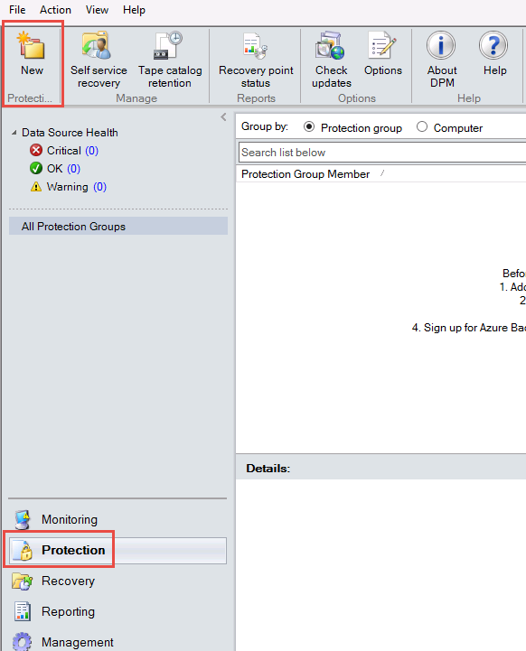

- In the Create New Protection Group wizard, click Next on the Welcome to the New Protection Group dialog.

- In the Select Protection Group Type dialog, select Servers and then click Next
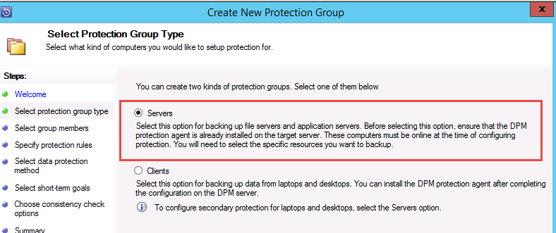

- In the Select Group Members dialog, expand the AB-HOL-SQL-PS SQL server where the SQL databases to be backed up are installed. DPM shows various data sources that can be backed up from that server. Expand the All SQL Servers. Select the SQL databases to be backed up.
- Ensure that the HRDB is selected as they would be required in the next exercise recovery scenarios when these databases are lost. Click Next.
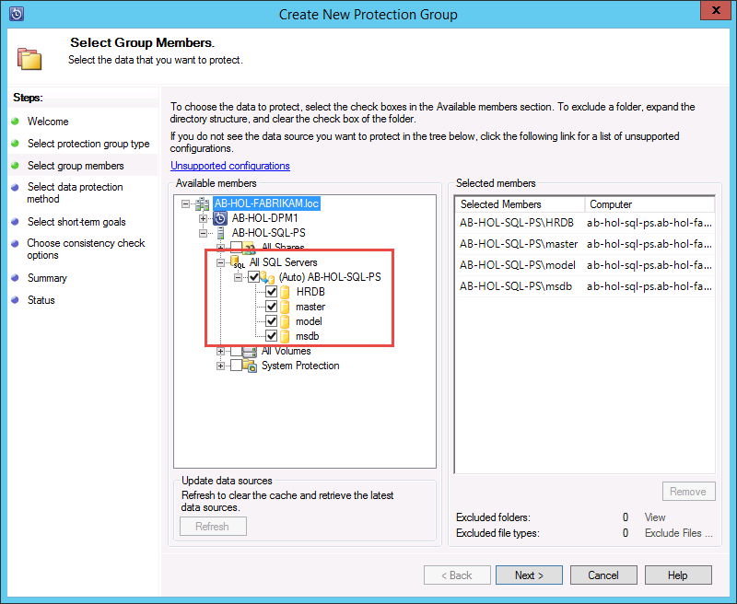
- In the Select Data Protection Method dialog, type SQLDatabaseBackup as the name for the protection group you are going to create. Ensure “I want Online Protection” option is selected and click Next:
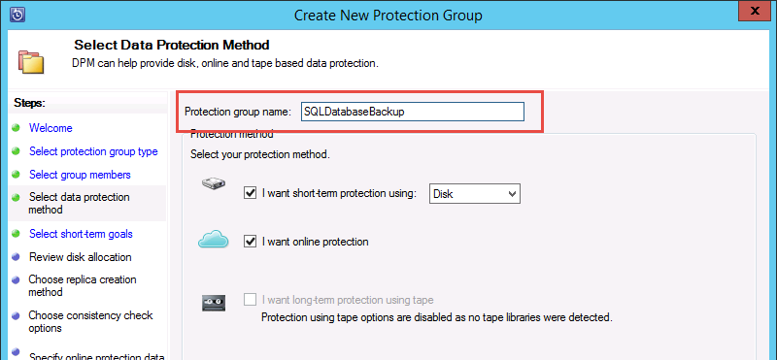
- In the Specify Short-Term Goals dialog, accept the defaults and click Next.
- In the Review Disk Allocation dialog, accept the defaults and click Next.
- In the Choose Replica Creation Method dialog, accept the defaults and click Next.
- In the Consistency check options dialog, accept the defaults and click Next.
- In the Specify Online Protection Data dialog, select all members and then click Next:
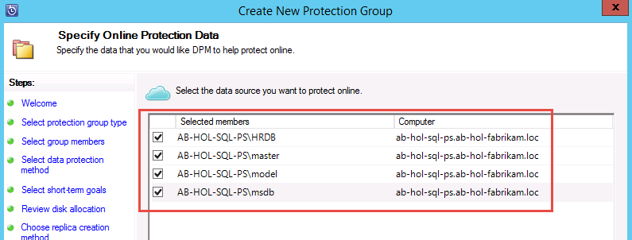
- In the Specify Online Backup Schedule dialog, accept the defaults and click Next.
- In the Specify Online Retention Policy dialog, accept the defaults and click Next.
- In the Choose Online Replication dialog, accept the defaults and click Next.
- In Summary dialog, accept the defaults and click Create Group.
- Watch the status and wait until the group finishes creating.

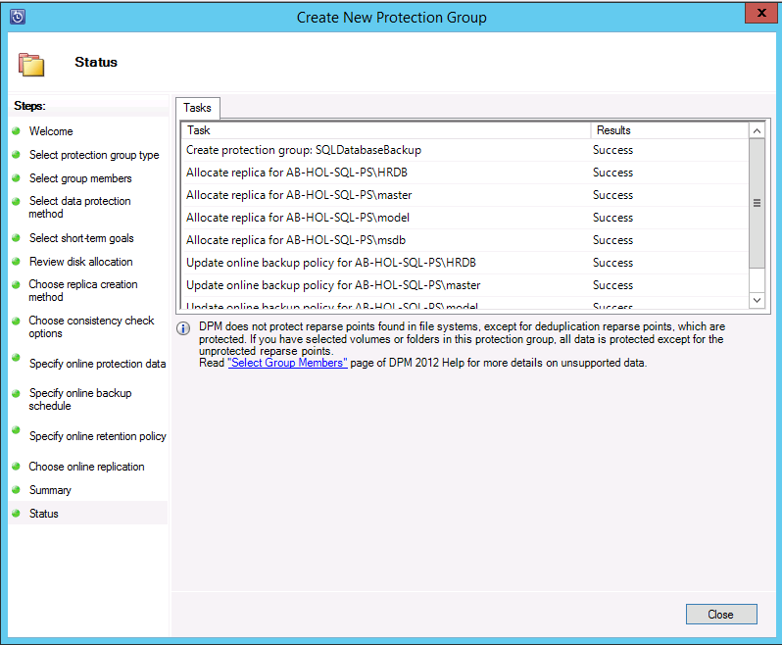

Exercise 4: Restoring Databases using DPM and Microsoft Azure

The time to complete this module, including exercises, is 30 minutes.
The key takeaways from this lab are:
- Recovering Databases from Microsoft Azure using System Center Data Protection Manager

Manually Create a Recovery Point
While the previous exercise created a backup policy, a “recovery point” is created only when the first backup happens. Rather than waiting for the scheduler to kick in, this exercise walks through the steps required to trigger the creation of a recovery point manually.

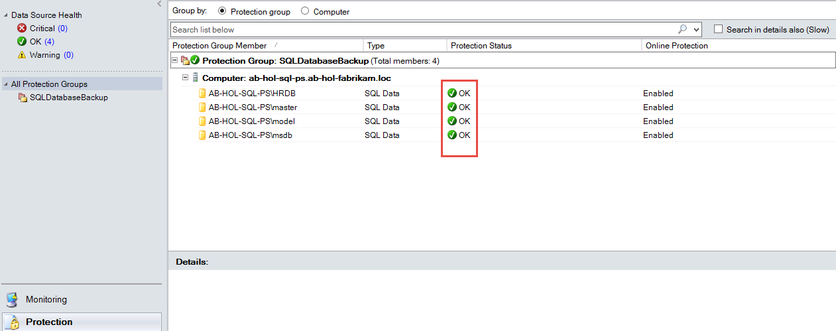

- Right-Click on AB-HOL-SQL-PS\HRDB and select Create Recovery Point. Choose Online Protection in the drop down and Click OK. This starts the creation of a recovery point in Microsoft Azure.
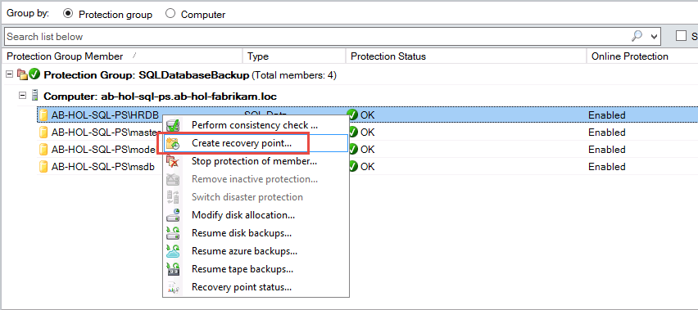

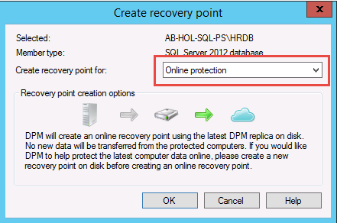
- You can view the job progress in the Monitoring workspace. Wait for the job to finish before proceeding.
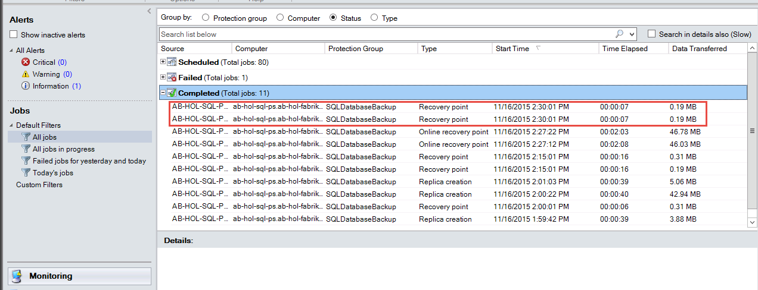

Delete the Database

- Before initiating a recovery workflow, let’s simulate a “disaster” by deleting the SQL database. To achieve this, Login to AB-HOL-SQL-PS Server.

- Once you log in to the SQL server, search for SQL Server Management Studio and open the application. (Note: SQL Server Management Studio should be attached to the toolbar.)
- The Connect to Server dialog should look like this:

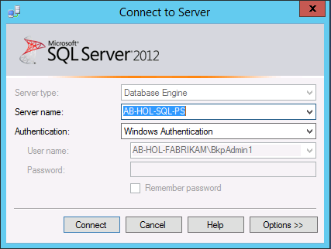

- Click on Connect.
- Expand Databases in the left-hand tree. Right-Click on the HRDB database and then select Delete.

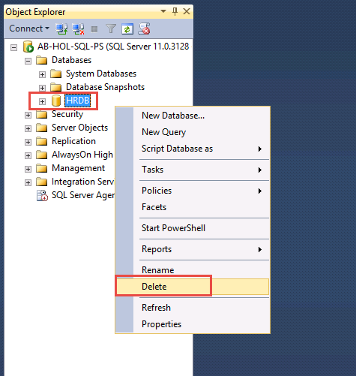

- In the Delete Object dialog, click OK.

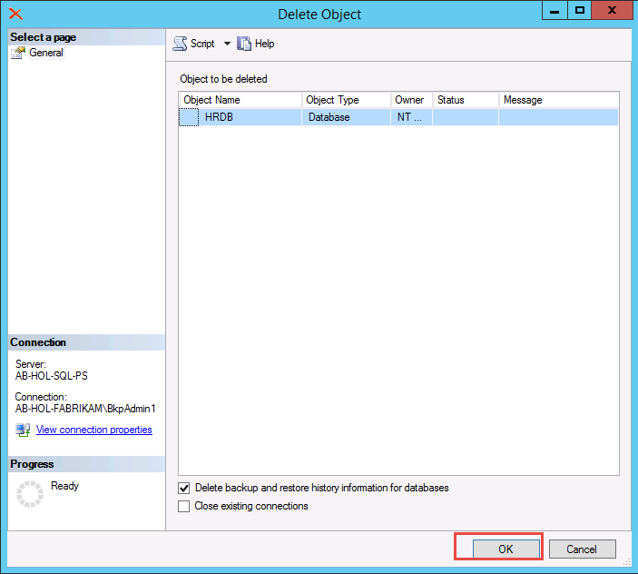

- Verify that the database was deleted.

Recover the Database

- To initiate the recovery workflow, login to the DPM server AB-HOL-DPM1

- In the DPM Console, navigate to the Recovery workspace where you will be able to see the servers backed up by DPM. Browse the database, HRDB. Select Recovery from time which ends with Online.

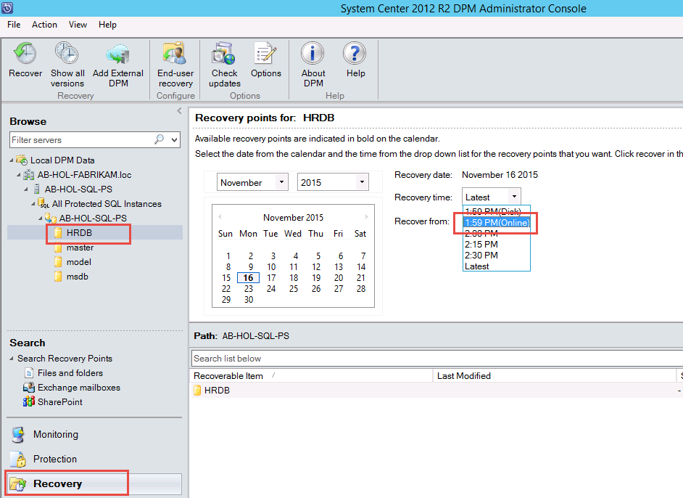

- Right-click on the HRDB database name and click Recover

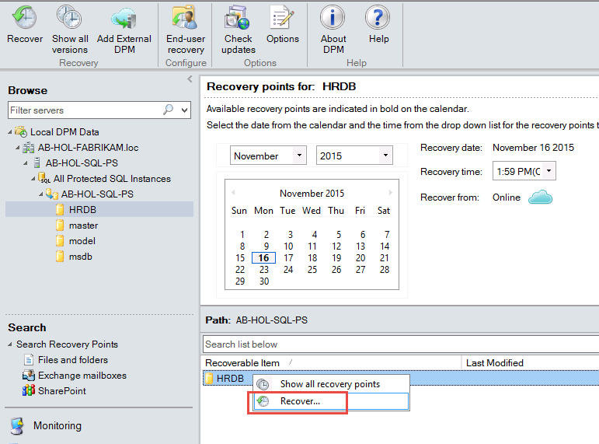

- In the Recovery Wizard, on the Review Recovery Selection dialog, click Next.

- In the Select Recovery Type dialog, select Recover to original instance of SQL Server (Overwrite database) and then click Next.
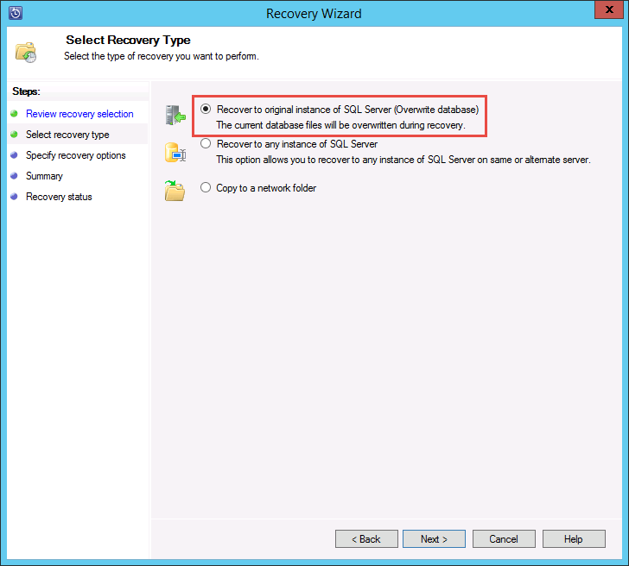

- In the Specify Recovery Options dialog, leave the defaults and click Next.

- In the Summary dialog, review the selections and then click Recover.

- Wait until recovery has completed. After recovery is completed, you can log onto AB-HOL-SQL-PS and verify that the database has been recovered. (Note: You will have to refresh your view in SQL Server Management Studio in order to see the recovered database.)

Appendix A - Post-protection activities

Installation of the backup extension
The Azure Backup service seamlessly handles the upgrade and patching of the backup extension without requiring any cumbersome user intervention. This relieves the user of the "agent management overhead" that is typically associated with backup products.

Offline VMs
The backup extension is installed if the VM is running. A running VM also provides the greatest chance of getting an application consistent point. However, the Azure Backup service will continue to back up the VM even if the VM is turned off and the extension could not be installed (aka Offline VM). The impact is seen in the consistency - in such a case the recovery point will be Crash consistent.

Initial backup
Once the virtual machine is protected with a policy, it shows up under the Protected Items tab with the status of Protected - (pending initial backup). By default, the first scheduled backup is the initial backup. In order to trigger the initial backup immediately after configuring protection, use the Backup Now button at the bottom of the Protected Items page.
The Azure Backup service creates a backup job for the initial backup operation. Click the Jobs tab to view the list of jobs. As a part of the backup operation, the Azure Backup service issues a command to the backup extension in each virtual machine to flush all writes and take a consistent snapshot.
Once the initial backup is completed, the Protection Status of the virtual machine in the Protected Items tab will show as Protected.
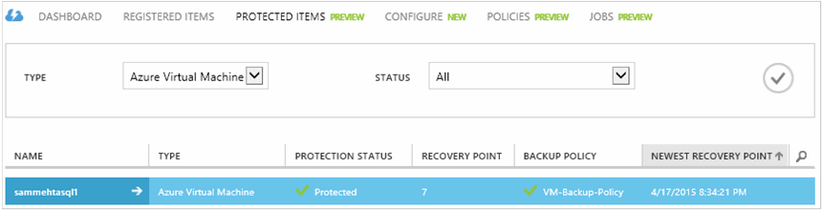

Viewing backup status and details
Once protected, the virtual machine count also increases in the Dashboard page summary. In addition, the Dashboard page shows the number of jobs from the last 24 hours that were successful, have failed, and are still in progress. Clicking on any one category will drill down into that category in the Jobs page.
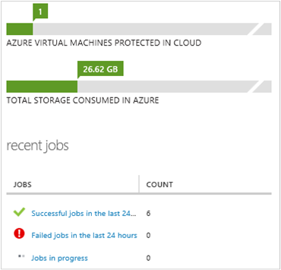

Long term retention
Retention policy specifies the duration for which the backup must be stored. Rather than just specifying a “flat retention” for all backup points, customers can specify different retention policies based on when the backup is taken. For example, the backup point taken at the end of each quarter may need to be preserved for a longer duration for audit purposes while the backup point taken daily, which serves as an operational recovery point, needs to be preserved for 90 days.
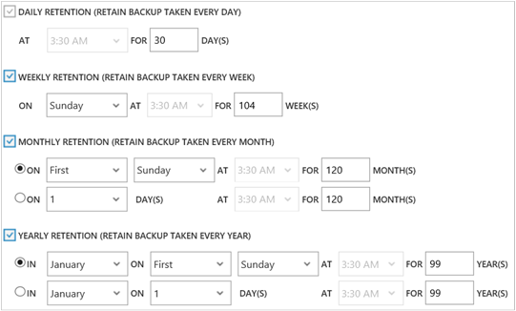
- Daily retention policy: Backups taken daily are stored for 30 days.
- Weekly retention policy: Backups taken every week on Sunday will be preserved for 104 weeks
- Monthly retention policy: Backups taken on the last Sunday of each month will be preserved for 120 months
- Yearly retention policy: Backups taken on the first Sunday of every January will be preserved for 99 years.

Appendix B - Consistency of recovery points
When dealing with backup data, customers worry about the behavior of the VM after it has been restored. The typical questions that customers ask are:
- Will the virtual machine boot up?
- Will the data be available on the disk (or) is there any data loss?
- Will the application be able to read the data (or) is the data corrupted?
- Will the data make sense to the application (or) is the data self-consistent when read by the application?
The following table explains the types of consistency that are encountered during Azure VM backup and restore.
CONSISTENCY | VSS-BASED | EXPLANATION AND DETAILS
Application consistency | Yes | This is the ideal place to be for Microsoft workloads as it ensures:  - That the VM boots up.  - There is no corruption.  - There is no data loss.  - The data is consistent to the application that uses the data, by involving the application at the time of backup - using VSS.  The Volume Snapshot Service (VSS) ensures that data is written correctly to the storage. Most Microsoft workloads have VSS writers that do workload-specific actions related to data consistency. For example, Microsoft SQL Server has a VSS writer that ensures the writes to the transaction log file and the database are done correctly.  For Azure VM backup, getting an application consistent recovery point means that the backup extension was able to invoke the VSS workflow and complete correctly before the VM snapshot was taken. Naturally, this means that the VSS writers of all the applications in the Azure VM have been invoked as well.  Learn the basics of VSS dive deep into the details of how it works.
File system consistency | Yes - for Windows machines | There are two scenarios where the recovery point can be file-system consistent:  - Backup of Linux VMs in Azure, since Linux does not have an equivalent platform to VSS.  - VSS failure during backup for Windows VMs in Azure.  In both these cases, the best that can be done is to ensure that:  - The VM boots up.  - There is no corruption.  - There is no data loss.  Applications need to implement their own "fix-up" mechanism on the restored data.
Crash consistency | No | This situation is equivalent to a machine experiencing a "crash" (through either a soft or hard reset). This typically happens when the Azure virtual machine is shut down at the time of backup. For Azure virtual machine backup, getting a crash-consistent recovery point means that Azure Backup gives no guarantees around the consistency of the data on the storage medium - either from the perspective of the operating system or from the perspective of the application. Only data that already exists on the disk at the time of backup is what gets captured and backed up.  While there are no guarantees, in most cases the OS will boot. This is typically followed by a disk checking procedure like chkdsk to fix any corruption errors. Any in-memory data or writes that have not been completely flushed to the disk will be lost. The application typically follows with its own verification mechanism in case data rollback needs to be done. For Azure VM backup, getting a crash consistent recovery point means that Azure Backup gives no guarantees around the consistency of the data on the storage - either from the OS perspective or the application's perspective. This typically happens when the Azure VM is shut down at the time of backup.  As an example, if the transaction log has entries that are not present in the database, then the database software does a rollback till the data is consistent. When dealing with data spread across multiple virtual disks (like spanned volumes), a crash-consistent recovery point provides no guarantees for the correctness of the data.

