Fast Start for Microsoft Azure - SQL Server IaaS
Demo - SQL Database and App on a single Azure VM
Prepared for
Update [Customer] in Doc Properties
[Enter Document Creation/Update Date Here]
Version 0.1 Draft

Prepared by
[Type Author Here]
Update [Author Position] in Doc Properties
Update [Author Email] in Doc Properties

Contributors
Update [Contributors] in Doc Properties

Revision and Signoff Sheet
Change Record
Date | Author | Version | Change Reference
 |  | .1 | Initial draft for review/discussion

Reviewers
Name | Version Approved | Position | Date

Table of Contents
Contents
1 Summary 1
2 Demo environment configuration steps 2
2.1 Create a SQL Server 2012 VM on the Windows Azure portal 2
2.2 Configure the VM firewall 6
2.3 Install pre-requisites for the .Net StockTrader application 8
2.4 Install the .Net StockTrader application 10
3 References 19

- Summary
This document covers configuring StockTrader application (both database and Web application) to run on a single Azure VM.
For this demo, you will need to create a SQL Server 2012 VM on Windows Azure. This document will lead you through the steps necessary to configure the virtual machine to host the application, and ultimately install the .Net StockTrader application on a single VM.
- Demo environment configuration steps
Setting up this demo breaks down to 4 basic steps detailed below. These are:
- Create a SQL Server 2012 VM on the Windows Azure portal
- Configure the VM firewall
- Install pre-requisites for the .Net StockTrader application
- Install the .Net StockTrader application
  - Create a SQL Server 2012 VM on the Windows Azure portal
- Access the Windows Azure portal.
Go to Windows Azure portal and sign-in. Use the credentials for which the Windows Azure subscription is configured.
The Windows Azure management portal can be found at: (https://manage.windowsazure.com/). If you do not have a Windows Azure account, visit Windows Azure 3-Month free trial.
- Create a SQL Server 2012 VM using the image available in the image gallery
This SQL Server 2012 VM will be used to restore to after a backup has been completed.
To build this VM, select the SQL Server 2012 SP1 Enterprise Windows Server 2012 image. This image is available by selecting Compute, then select Virtual Machine, then select From Gallery.
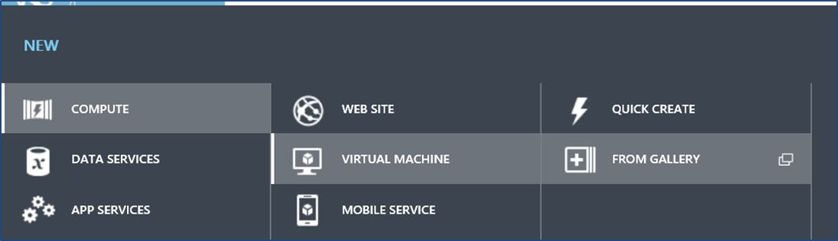
You can scroll down the list of available VMs, or select SQL Server from the tree on the left to filter the gallery list. Select the SQL Server 2012 SP1 Enterprise Windows Server 2012 image, and press the next () button.
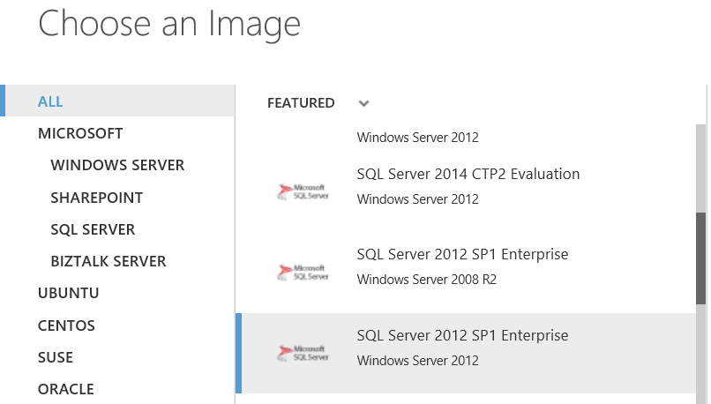
- Provide the VM configuration details, and press the next () button.
Take note of the virtual machine name you enter here because it will be used later.
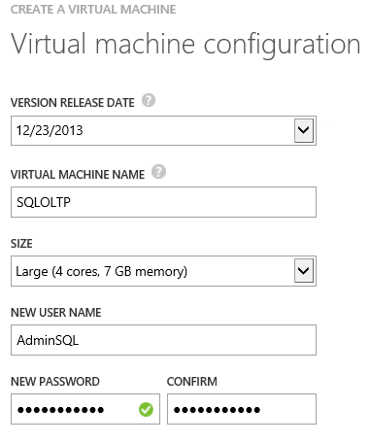
- Enter the VM configuration details, and press the next () button.
If your server name is not unique to your network, change the cloud service DNS name to a name that is unique. Also, specify a region local to the geography of the demo.
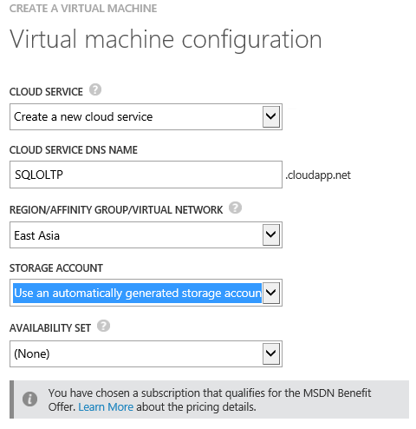
- Finalize the creation of the VM by pressing the ok () button.
Use the default settings on the last page of the wizard and complete the creation of the VM by pressing the OK button.
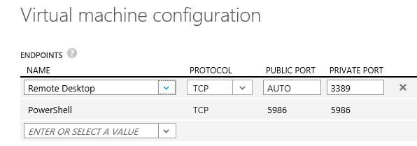
- Verify that the VM has been created successfully.
Select Virtual Machines from the left-hand tree control to display all the virtual machines for this Windows Azure account:
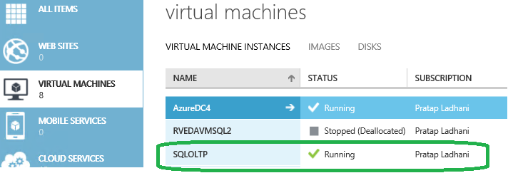
Note: If you are not going to perform this demo immediately, be sure to shut down any virtual machines until they are needed to prevent accrual of billed time against the VM.
  - Configure the VM firewall
To enable connection to the SQL Server from on-premises applications, you must open port 1433 on the SQL Server VM. The following steps will lead you through this.
- Log in to SQLOLTP VM and open firewall settings
- Create an inbound rule for the TCP port 1433 to allow connections
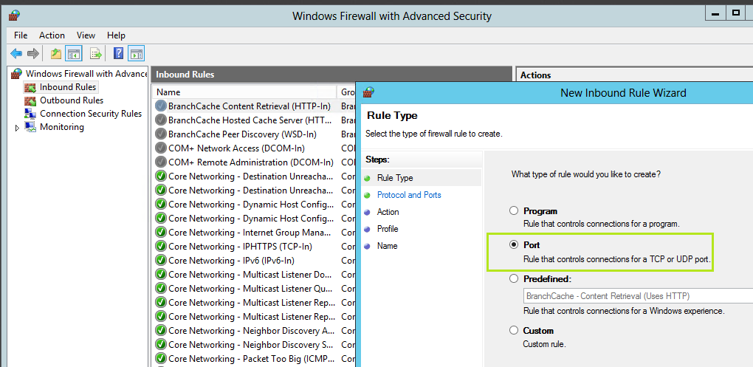
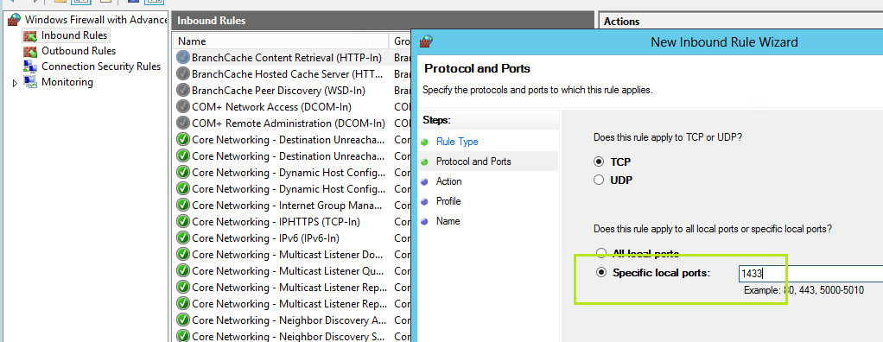
- Follow the default values on the wizard for the next steps and name the rule ‘SQL TCP’ and click OK.
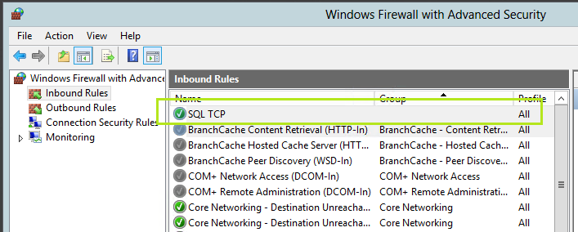

Alternatively, you can use execute this PowerShell cmdlet to configure inbound firewall rule:
Write-Host "Configuring firewall..."
netsh advfirewall firewall add rule name='SQL Server (TCP-In)' program='C:\Program Files\Microsoft SQL Server\MSSQL11.MSSQLSERVER\MSSQL\Binn\sqlservr.exe' dir=in action=allow protocol=TCP
Write-Host "Firewall configured."
  - Install pre-requisites for the .Net StockTrader application
Verify and/or install the following pre-requisites for the StockTrader application:
- Log in as administrator
Log onto the VM created in step 2.1 above as an administrator.
- Install .NET Framework 4.5 runtime
You must have the complete .NET Framework 4.5 runtime installed; not just the client profile. This is available for free download on MSDN. You can download it from here and install it.
- Configure SQL Server Mixed Mode Authentication
The application requires SQL Server Authentication mode (Mixed Mode Authentication) to be enabled. Right click on the Server Name in SQL Server Management Studio, then click on Properties. On the Server Properties, go to Security page and check the “SQL Server and Windows Authentication Mode” as shown below.
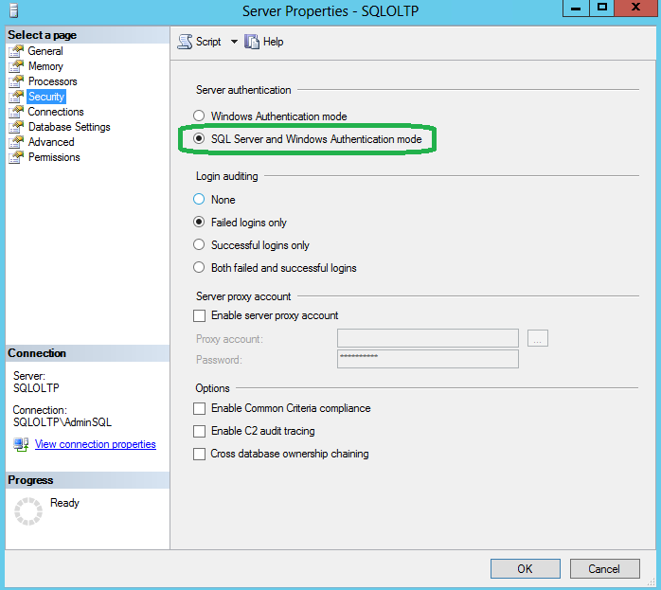
- Install IIS Web Server
IIS Web Server is required for the .Net StockTrader application. Install this as a Windows feature with ASP.NET enabled. Also, please make sure you have selected IIS as an installed Windows feature, as setup will create virtual directories for you. The IIS Web Server can be installed via Control Panel/Add Remove Programs, Turn Windows Features On or Off.
Within the IIS selectable features, make sure you select, at a minimum:
- IIS WMI Compatibility (required by Visual Studio for Web applications)
- IIS Metabase and IIS 6 Configuration Compatibility (required by Visual Studio for Web applications)
- IIS Management Console
- IIS Management Service
- IIS Management Scripts and Tools
- .NET Extensibility
- ASP.NET
- ISAPI Extensions
- ISAPI Filters
- Default Document
- Directory Browsing
- Static Content
- Basic Authentication
- Windows Authentication
- Windows Process Activation - Select all three sub-features.
  - Install the .Net StockTrader application
The final preparation step for this demo is to install the application itself. You can download and install the application by following these steps:
- Connect to the VM
The following steps will occur on the VM created in step 2.1 above. Connect to this VM using a remote client.
- Download the .NET StockTrader application installation MSI
Download the installation MSI and save it to the VM local drive. The MSI can be downloaded from here.
- Begin the StockTrader installation.
Double-click on StockTrader6 MSI file to start the installation as shown below:
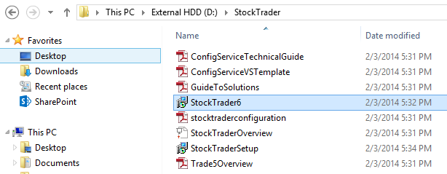
- Advance past the welcome screen.
Click on Next button on Welcome page of the installer as shown below:
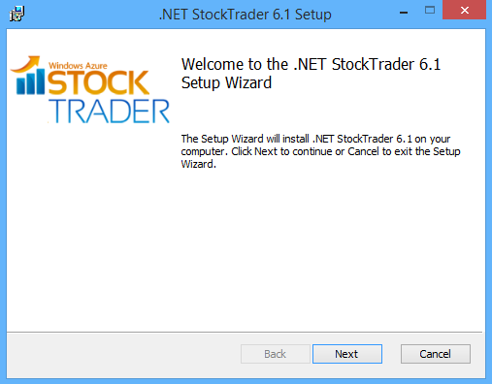
- Accept the License Agreement and proceed
On the End-User License Agreement page, check I accept the terms in the License Agreement checkbox and then click on Next button as shown below:

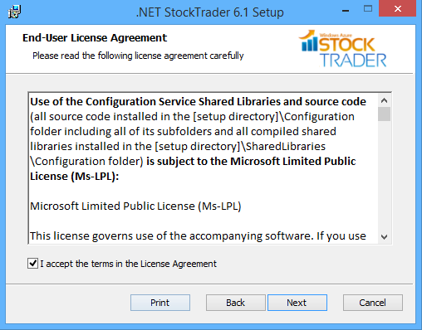
- Verify pre-requisite setup
Double-check the pre-requisites have all been installed and configured as mentioned on this page as shown below:

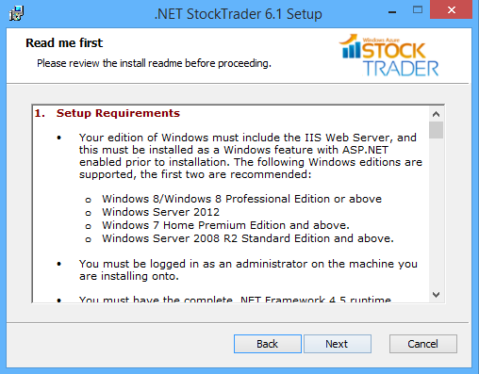
- Set an installation location
On the Custom Setup page of the wizard, select the location to install the application. Please ensure you are specifying a location which is not a temporary location as shown below:

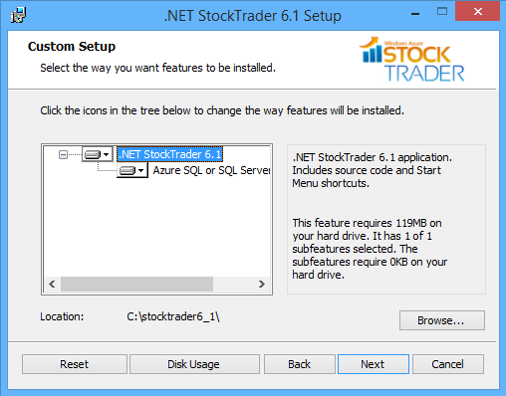
- Configure StockTrader for use with IIS
Select the Configure StockTrader for use with IIS radio button and click on Next button as shown below:

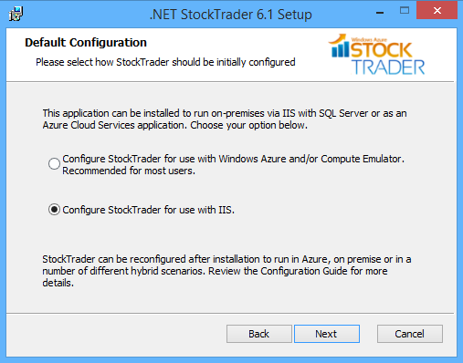
- Specify the SQL Server connection information
On the SQL Databases page of the wizard, you need to provide the connection information for the server created in step 2.1 above. Provide the SQL Server instance name and credentials (SQL User) to connect to the SQL Server and then click Next button as shown below:

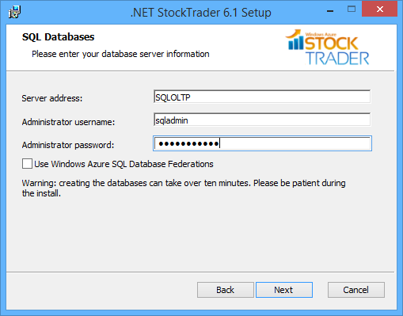
- Finalize the installation.
On the Ready to install .NET StockTrader 6.1 page of the wizard, click the Install button as shown below. This will kick off the installation and will report the installation progress. After installation, by default it will take you to read me page where you can find more information about this sample application.

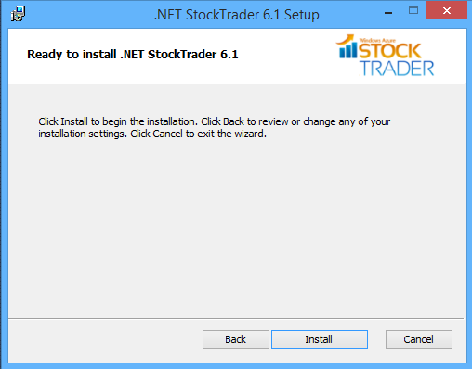
- Verify database creation
After installation, you can go the specified SQL Server instance and verify the databases created as shown below:

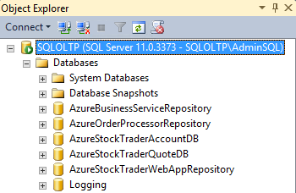
- Launch the application
Now you can launch the application and this is how it should appear. For the first time, you need to register and then login with your registered credentials:
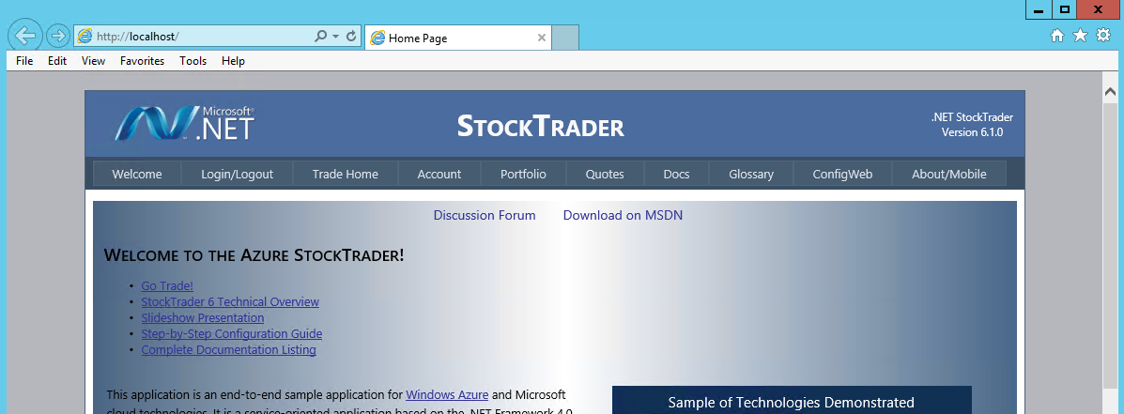
- References
- SQL Server Deployment in Windows Azure Virtual Machines
- .NET StockTrader Sample Application download

